SMART NAVIGATION SYSTEM

Report by Sreekanth Nambu and Shalini Toopran
CS 556 Distributed and Pervasive Computing

Introduction:

Our project Smart Navigation System is implemented and developed based on two important features, namely Google Maps and GPS using the platform Android mobile operating system. Our Main aim of the project is to integrate google maps with the android phones integrated features. Android is a mobile operating system running on the Linux kernel. It was initially developed by Android Inc., a firm later purchased by Google, and lately by the Open Handset Alliance. It allows developers to write managed code in the Java language, controlling the device via Google-developed Java libraries.
Google Maps: is a basic web mapping service application and technology provided by Google, free (for non-commercial use), that powers many map-based services, including the Google Maps website, Google Ride Finder, Google Transit, and maps embedded on third-party websites via the Google Maps API. It offers street maps, a route planner for traveling by foot, car, or public transport and an urban business locator for numerous countries around the world.
GPS: Global Positioning System (GPS) is a U.S. space-based radio navigation system that provides reliable positioning, navigation, and timing services to civilian users on a continuous worldwide basis. It is freely available to all. For anyone with a GPS receiver, the system will provide location and time. GPS provides accurate location and time information for an unlimited number of people.

 Smart Navigation System:

The above fig. is our Apps icon on the Android menu. Our Application includes features such as location finder, current location finder, establish a connection between the current location and the destination location at the touch of a button, from the map details of the particular location such as road no., phone no, location address etc. A mobile call can be easily performed by a touch on the location address. Even messages along with image information regarding the visited places or interesting locations can be send to the friends with the

touch of a button directly from the GPS map. This facilitates easy access and smart way of interacting with the google maps and phones integrated features. The Application is useful and helpful for people who has frequent itineraries and for people who visits countries around the world. The following discusses the functionality and features of our Android Application.

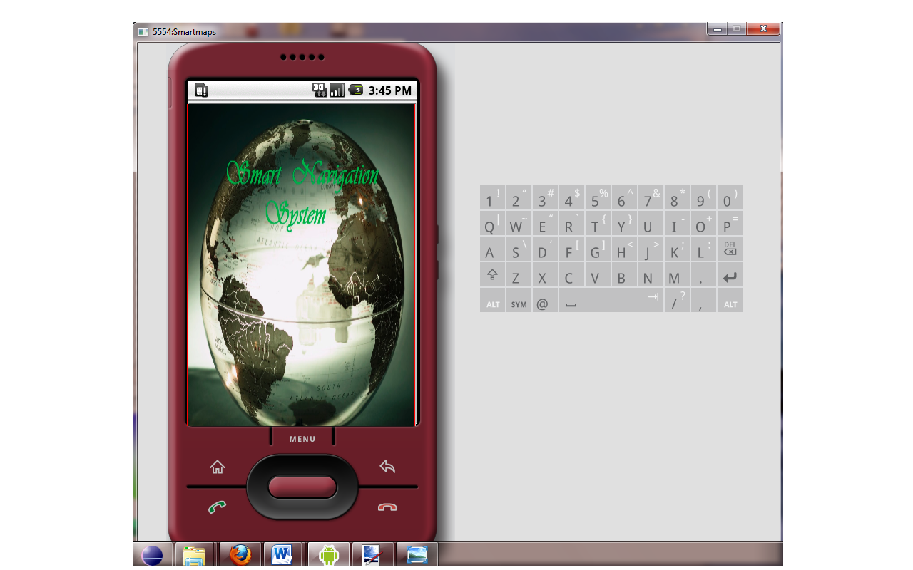

Fig.1. Smart Navigation System App.
This project integrates various features into the application to provide wide range of functionalities to the end users. The following screenshot shows the home screen of the application, smart navigation system. When a user clicks on menu and selects smart navigation system, a sequence of five buttons is displayed on the emulator. They are: Most visited, Current location, GPS Navigation, Make a call and Write a message.
The following screenshot shows the resulting screen with all the five buttons:

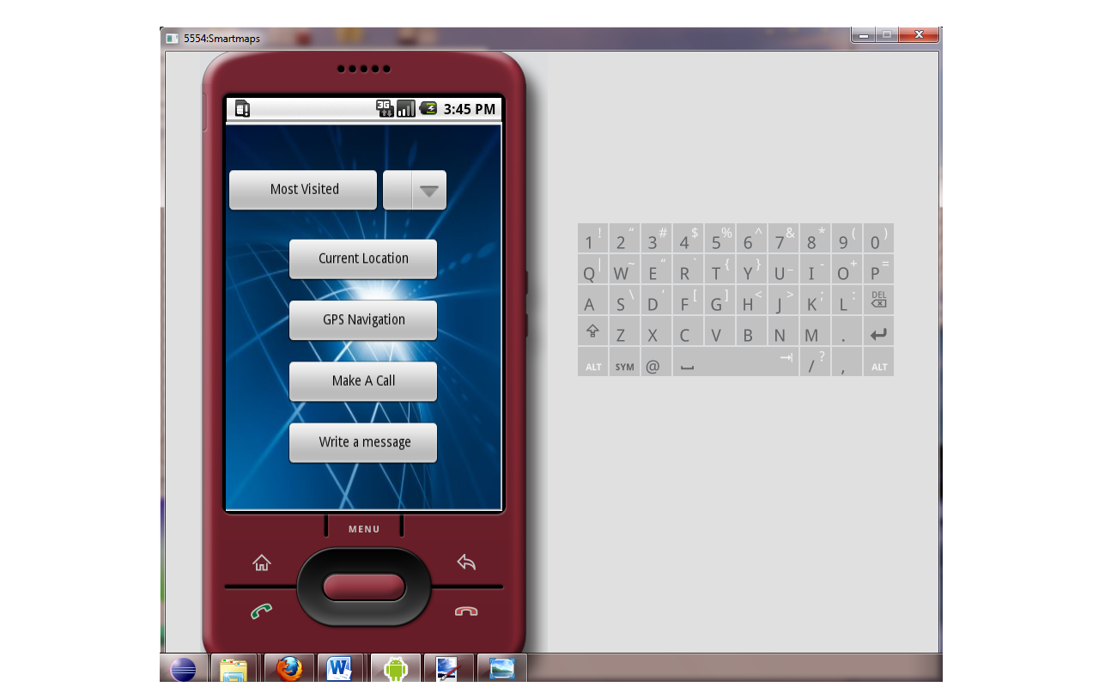

Fig.2. Smart Navigation System opening tab

Most Visited:

Fig.3 shows most visited button: clicking the button displays a list of frequently visited locations. The location can be selected from the drop down list next to the most visited icon. This project displays a list of locations which are hard coded. A click on any of the locations will display its corresponding map. The map can be scrolled or enlarged for viewing a wider range. A click on any location on the map displays its address. When a user clicks the menu button on the emulator, a menu named ‘Gallery’ pops up at the bottom of the screen. By clicking on this menu, a photo gallery of the selected location is displayed.

Current Location:

A click on this buttons opens the current location of the user. A pushpin at the center of the map displays the exact location of the user. This feature is available in iPhone, Android mobile platforms to find the exact current location of the individual anywhere in the world. The app. can be used to establish connection between user locations to the destination as shown in fig.4.

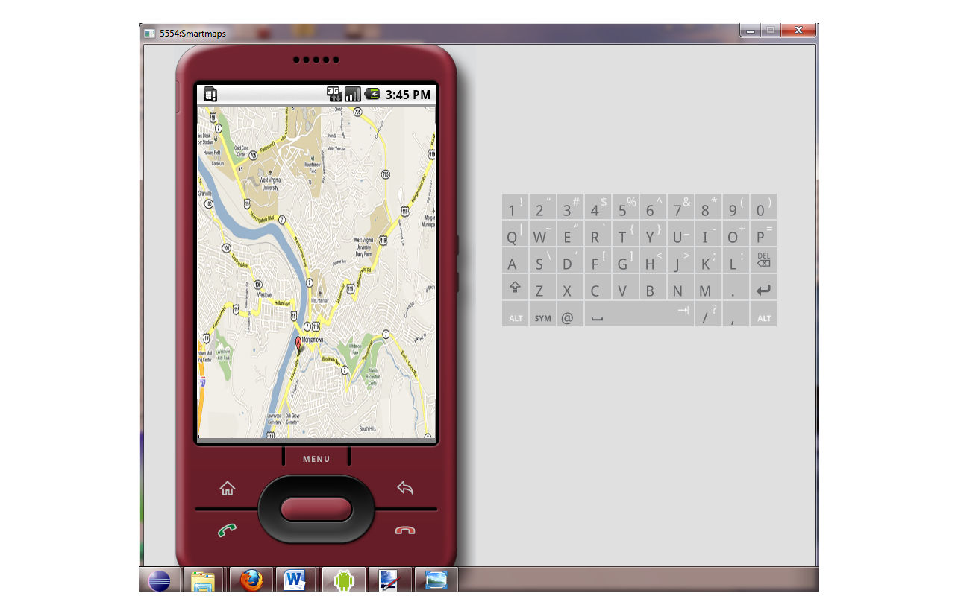

Fig.3. Current Location finder

GPS Navigation:

This button displays the Google maps. All the functionalities provided by Google maps can be used here. This is called using intent.
The following screenshot show the map with location at Morgantown.
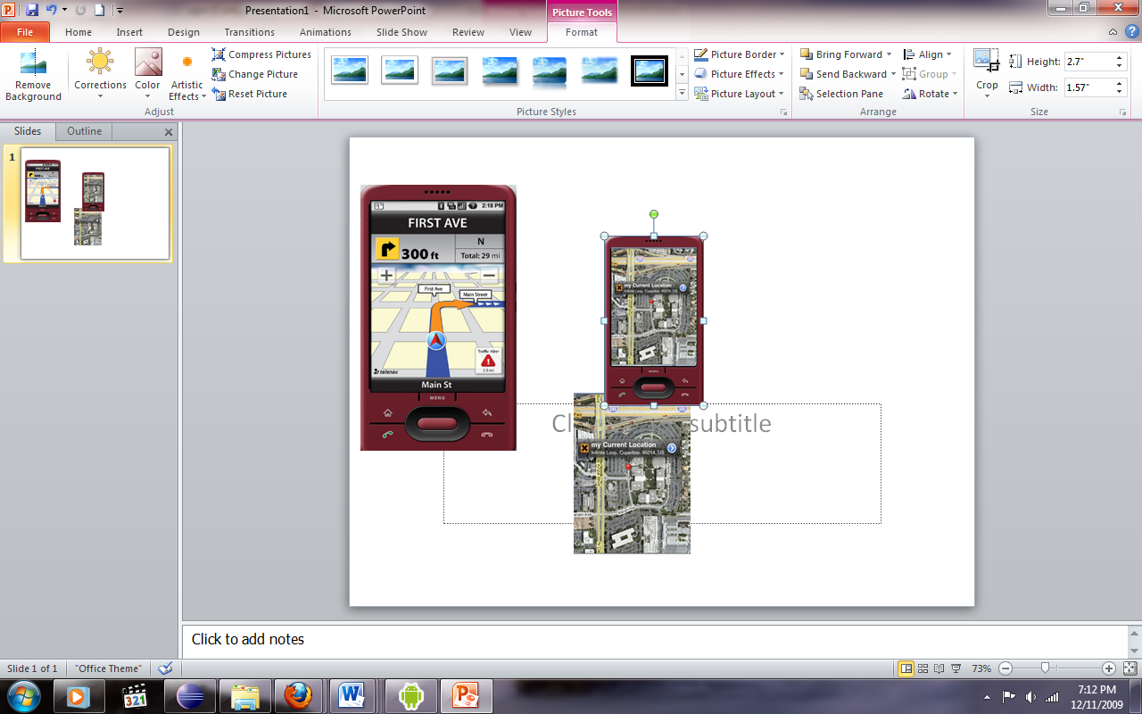

Fig.4. GPS Navigation System

Make a call:

This option allows the user to directly make a call without exiting the application. Selecting this option will not terminate or contradict with the GPS navigation.
The following screenshot appears when a number is dialed. The user can make a call directly by touching the map locations which shows the location address, name and phone number.

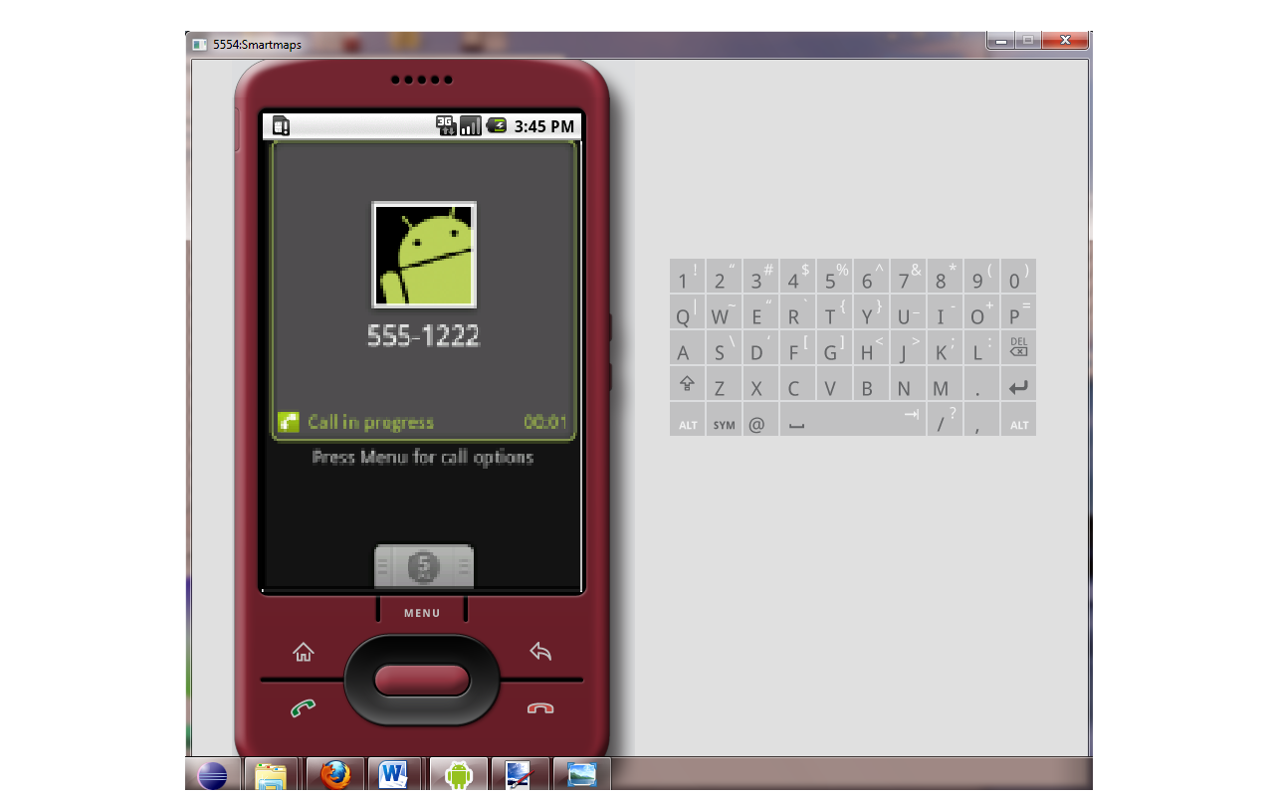

Fig.5 Make Call functionality

Write a message:

This option is similar to sending an SMS. A user can send a message without exiting the application. The following screenshot shows the page displayed when write a message button is selected.
This feature can be further extended by sending pictures to friends by directly tapping the locations images with that of the gallery in the mobile system.

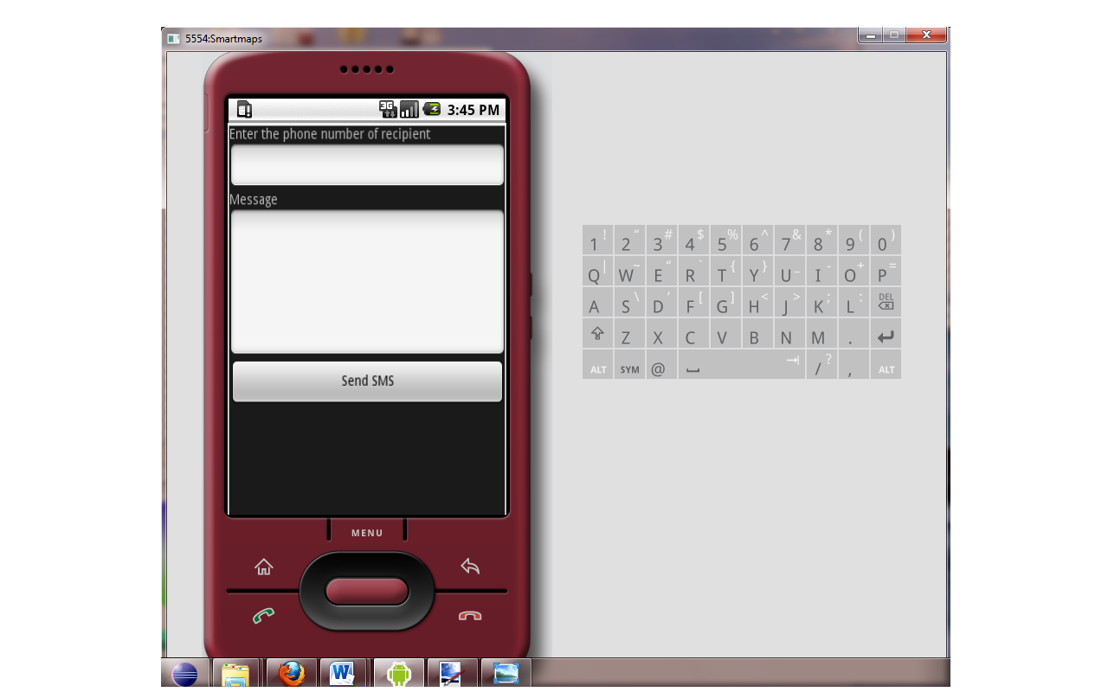

Fig.5 Send SMS to friends

Future Enhancements:

This application can be further improved by implementing the following changes:
The most visited icon should be able to retrieve the frequently visited locations from the database and display the list to the user. The gallery option could be given a user interface, where in, a user can directly attach images of the places he visits. He may take a step further and forward the images by using the write a message option.
This Application gives an important vision of developing mobile applications more intuitively and intelligently and our application deals and improvises the existing APIs like Google APIs more intelligently and innovatively.

